Work Instruction for certification usage of welding machine and portable tools and hand lamps and halogen fittings

Objective: Certification/Usage of portable Equipments.

Scope: Welding machines, portable tools, hand lamps and halogen fittings.

Ref: Indian Electricity rule

Responsibility: Electrician

- Aspect: Waste generation
- Impact: Resource depletion
- Hazards: Electric. Shock

CERTIFICATION

- WELDING MACHINES

- Check for Incoming supply switch and ensure for proper rating and functioning.
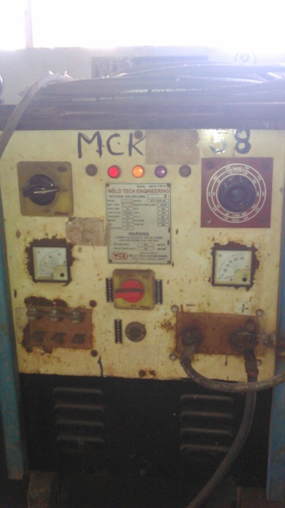

- Check for current indicator and ensure for visibility of scale and indicator.
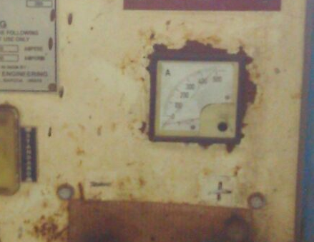
- Check for condition of incoming supply cable, ensure no joints in between/cable damage and proper glanding / termination by using P G type of gland
- Check and ensure for current regulating handle for functioning.
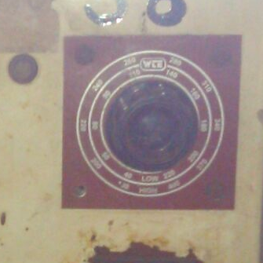
- Check and ensure the output cable for proper rating of current, for proper lugging with copper hole type lugs and for proper insulated welding holder. Minimum size of the welding cable shall be 50 sq mm flexible copper.
- Check and ensure overall condition of welding machines like lifting hooks, handle wheels etc.

- Check and ensure machines having identification number.
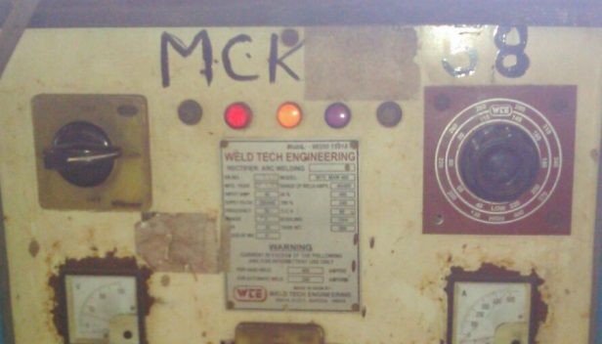
- Check for winding wires that they are insulated properly and are not touching to any parts or body of the welding machines.
- Check machine leakage voltage (body of machine to neutral), it shall not be more than 50 volts.
- During certification, if machine is found to be unsafe to use, disconnect the power cable and inform to the concerned.
- Check functioning of RCCB/ELCB which is fitted on welding machine for its proper functioning.

II PORTABLE TOOLS
- Check for condition of power cable; ensure no cable joint or cable damage.
- Ensure design Speed of grinding wheel used is equal or more than the speed of grinder mentioned on the machine.
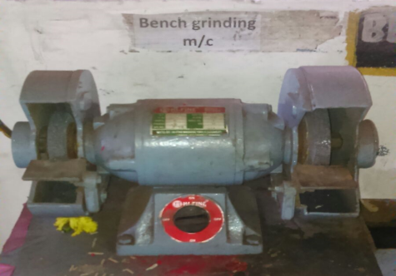
- Ensure power tools like pedestal drill machine, plate rolling machine, machine shop machineries etc shall have Electrical starters with emergency lockable stop push button. Such tools shall be certified jointly with mechanical engineer. Supply for such portable tools shall be provided through RCCB/ELCB only for human protection against electrocution.
- Check and ensure for proper functioning of power switch.
- Check and ensure for proper earthing of portable tools.(not applicable to hand grinders whose body is made from insulated material)
- Check and ensure each one of them is having identification number.
III HAND LAMPS/ HALOGEN FITTINGS

- Check for condition of power cable , ensure no cable joint/cable damage, protection glass etc., is in good condition.
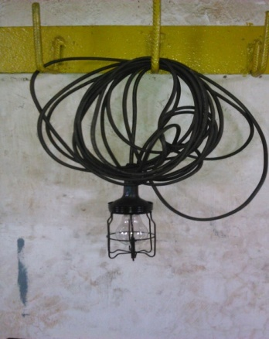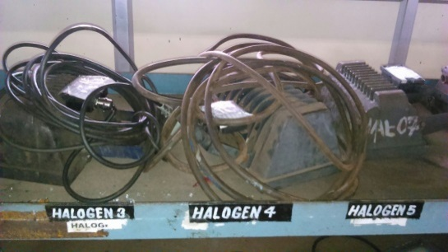
- Check and ensure for proper earthing (not applicable to hand lamps).
- Check and ensure it is having identification number.
- Halogen fittings flexible power supply cable shall be protected from heat near the halogen connection by inserting fiber glass sleeve at least for half meter length.
Equipment will be certified for use only after it is checked for above mentioned points and found to be suitable for use

IV WELDING CABLE & ACCESORIES

- Check & ensure it is having valid identification number.
- Welding cable used shall be 50mm2 copper cables with double insulation & shall confirm to specification as per IS-9857-1990. Welding cable should have minimum 25 mtrs length & shall be properly lugged.
- Welding cable holder shall be fully insulated having 600ams capacity & conforming to IS-2641-1989.
- Welding holder should be fully insulated & should have spatter guard for welder.
- Ground clamp for welding shall be 600amps & conforming to IS-2641-1989.
- Certification of welding accessories is valid for 3 months.

USAGE

- Only certified welding machines shall be used in the plant. Welding machines shall be kept on dry surface. During rainy season, wherever possible machine shall be kept inside the shed or shall be covered with canopy for rain protection. User shall maintain/overhaul the machines regularly through third party or electrical department to ensure healthiness of winding insulation, cooling fan motor, current regulation etc.
- Welding output cable shall be connected to machine terminals by using proper size (12 mm min) nut bolt duly tightened by using spanners. Crimping of welding cable lugs shall be done by using crimping machine available with Electrical dept. However, on request, Dept. Electrician may be arranged at site for crimping cable lugs.
- Welding supply plug top shall be plugged into the socket only by the welder to ensure it is fixed and tightened properly, if it is loose, it will create sparking and finally burn.
- No welding machine/ portable hand lamps, halogens, portable tools shall be connected without plug top. Inserting wires into the supply socket without plug top is very dangerous and same is strictly prohibited.
- Only certified 24 volt AC portable hand lamps shall be used in the plant. Usage of 230 volt supply portable hand lamps is strictly prohibited.
- Only certified portable Halogen fittings duly mounted on a standard halogen stand shall be used for giving temporary illumination. Shifting of portable halogen fitting when it is ON condition is strictly prohibited and shifting of such portable halogens shall be done after switching off the lights by Electrical dept employees only.
- Portable halogens/ tools like grinder, drill machines and any other portable tools shall be connected to the 220 volt AC supply only through the RCCB for human protections against Electrocution,
- Only certified 220 volts supply Extension boards shall be used, duly fitted with RCCB for human protection against Electrocution.
- User /owner of such portable equipment like welding machines, hand lamps, halogen fittings, portable hand grinder, drill machine will have to get it certified from SSL Electrical dept. prior to the due date of certification mentioned on the certification tag. User dept shall maintain a list of such all portable equipments with them for their ready reference.
- Usage of halogen light or any other portable light fitting operating on 230 volts supply are not allowed for usage inside the close vessel or Silo’s. Only 24 Volts hand lamps are allowed.

Amendement Record
Date | Manual Section Ref. & Para | Brief details of Revision | New Rev.

Prepared By:  Senior Elect. Engineer | Reviewed & Issued By:  Management Representative | Approved By:  Head – Electrical & Instrumentation PID I
Signature | Signature: | Signature:
Review Date: 04.03.2023 | Review Date: 04.03.2023 | Review Date: 04.03.2023

